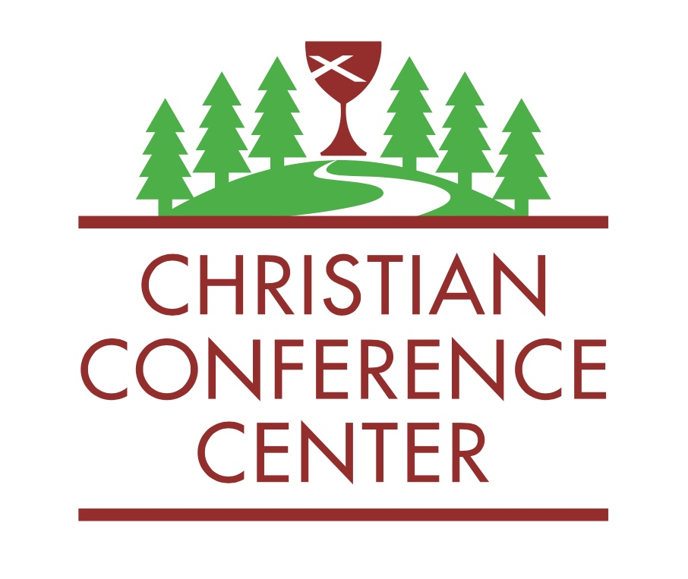
February 1, 2023

Dear Brothers and Sisters in Christ,

We at the Disciples Regional Office and the Christian Conference Center are getting excited for another great summer on Holy Ground! In this packet you will find all the information you need to promote Summer Camp 2023. Below are a few notes that are important for anyone who helps promote camp or process camp registrations in your congregation. Please show this packet to your youth leaders, Sunday school teachers, and pastor. Don’t hesitate to contact me with questions.

REGISTRATION REMINDERS
Online Registration ONLY This Year
This year, registrations will only be received through our online registration portal. The link to register is available on the CCC website and the Region’s website. If you need assistance with online registration, please call the camp office. Someone will assist you.

Adults Who Attend Grand Camp and Family Camp
Adults who accompany a child to Family Camp or Grand Camp must also register and pay to participate. Each individual should fill out their own online registration form. For optional Lodge Room upgrades, only one person in each party needs to pay the fee.

Coupon Codes
Does your church pay part of the registration fee for camp? When registering online, campers can select coupon codes of 50% or 100% off. If campers use a coupon code, they must specify their congregation and are asked to forward their confirmation email to their church’s camp registration coordinator. At any time, if you would like an update of your church’s registrations, our office can provide one. Email registration@uppermidwestcc.org to request a list.

Scholarships
Campers (or church leaders on their behalf) can request a scholarship by simply emailing me their name, camp session and amount requested. Please note: in order for our scholarship dollars to help as many kids as possible, we ask that the camper’s congregation pay 50% of their fee if possible. We want everyone to be able to attend camp! Once a scholarship is requested, the camper will be given an individualized coupon code by the regional office. No child will ever be turned away because they can’t pay.

Refund Policy Reminder
If a camper cannot attend their scheduled camp and can’t switch to another event, we are happy to refund their registration fee (-$20 processing fee). We do not refund fees for campers who simply do not show up for camp.

CAMP PROMOTION REMINDERS
Need More Copies?
For promotional materials, visit www. uppermidwestcc.org then click on the “Camp and Conference Center” tab. You’ll find lots of information there, including:
1. Digital, printable copies of all the items included in this packet
2. Bulletin Insert to help advertise camp
3. List of all camp dates and prices
4. Link to YouTube Camp Promo Video

Where do I send parents for information about camp?
For more detailed information designed for parents and campers, visit www.newtonccc.org. The information on the camp site is laid out to help these folks better understand what programs we offer. This is easier done on our camp website than the region’s.

Plan a Camp Sunday!
Would you like help with camp promotion in your congregation? I’m available most Sundays to visit your church and spread the Good News about church camp. I can also send a personalized video message and promotional giveaway items if that would be more convenient.

Why Are Camp Fees Higher?
Due to rising utility, food and labor costs, we had to make the tough decision to raise camp fees this year. Please know that we do not make these decisions lightly. Don’t forget that because of some amazing donors, scholarships are available for anyone who needs them. If you have questions about our fees, please reach out to me.

See you at camp,

Rev. Tiff Williams
Associate Regional Minister and CCC Camp Director
Email: tiff@uppermidwestcc.org
Office Phone: 641-792-1266

Items Included in This Mailer: 1. Camp Poster, 2. Camp Brochure, 3. Church Payment Cover Sheet, 4. Summer Camp Price Guide

